Proposed Architecture for Consumer Module for the Mossel Bay Website

Version: 1.0
Created by: Techseria
Created on: 19/11/2016
Modified on: 21/11/2016

Client:
Bluegrass Digital

Contents
Contents 2
Overview 3
Questions 3
User Actions 4
Proposed Architecture 5
User Profile 5
Consumer Account Content Type 5
Views module 6
Consumer 7
Consumer account dashboard 7
Account Transaction History 8
Consumer Account Details 9
Administrator 9
Administrator Functionality 9

Overview
The task is to convert the current PHP based scripts to Drupal module and to drupal standards. The specs are defined in “Consumer Module - Technical Process.docx”, provided by the client.

Questions
- The “Consumer Module - Technical Process.docx” document describes, “The system validates this information before adding/linking the accounts hence the 24 hour waiting period).“. How should this validation be done? Does this simply refer to the validation that is done as part of the import routine?
- We have not found any 3rd Party API in the code but it was mentioned in one of the Bluegrass spec docs. Can you confirm that there is no integration with any any 3rd party API to fetch any data or to perform validation on the data? (Aside from the CSV data being published)
- How are the users added to the system, is it only via the registration form on the site? Is there any method where users are created by the site admin or from the csv import process?
- We found the field names in the database do not clearly describe the field contents. Could a description of the less obviously named fields in the database tables be provided?
- Migration of consumer users from the existing application (core PHP) to Drupal (new system) will mean we need to create those existing users (consumers) in Drupal send them a one time login link. Is that acceptable? There may be other alternatives here if not. The existing consumer users have a login to access the system using email and password. Their current app stores the password in a different way to Drupal. So we would need to find a good solution to allow those users to be invited to the new system and choose a new password as we would not be able to import the old password from the original system as it is not stored in plaintext
- Are the CSVs that are published the complete data or just the changes since the last publish. If it is only the new data, we will need to import the existing data from the original system to the new one.
- Are the CSVs published each day? What time?
- There is functionality where a user (Consumer) can delete an account (property), what should we do if a CSV in the future has record for a deleted property?
- We are missing a file in the supplied code from their original system ‘csv2db-01.php’. Please could that be supplied?
- The utilities listed in the technical document they sent include electricity and water. Are there any others we need to include or are those the only ones?

User Actions
- Users are registered by import process
- Users are activated within 24 hours (approx) of the registration
- They are called consumers
- Consumers can have multiple accounts for their properties in the consumer dashboard
- Consumers can add a new account manually and they are validated against their name
- Consumers can see the meter reading data about each of their properties organised by date
- Consumers can edit their profile and change their password
- Consumers can see the details of one account and update details
- Consumers can remove their accounts

Proposed Architecture
For this module we will need to add fields to user profile and a content type. The “Consumer Module - Technical Process.docx” does not describe any other information about the user’s profile database table, so it’s based on the screenshots.

User Profile
Based on screenshots for Consumer’s profile in “Consumer Module - Technical Process.docx”, we assume following fields will be on the consumer user profile.

- Full Name/Company
- ID or Registration Number
- Contact Number
- Email Address

Consumer Account Content Type
We will create a content type called “Consumer Account” which will be used to add properties. A Consumer User will be able to add properties to this but for the most part, properties will be added by the import batch processes.

The content type will comprise of various fieldsets. Some fieldsets can be added more than one by a Consumer User. The content type will have following fields but can be changed based on the requirement and feedback before the development work commences. We will need to know the Labels to assign to these fields where they are not obvious.

- Account Information (Muncmf table is currently used to store in this information)
  - acc
  - st_name
  - St_no
  - name
  - addr1
  - addr2
  - addr3
  - pcode
  - m_or_y
  - owner
  - lang
  - Phone
  - print_acc
  - no_accts
  - active
  - erf_no
  - Rates_tarif
- Account Reading
  - ew
  - type (This will be category i.e. Electricity, Water etc)
  - meter_no
  - read (This field will be multiple add entry)
  - read_date (This field will be multiple add entry)
- Detail SBDF(Munsbdf table)
  - Suburb
  - Descr
- Detail DESC (Muntdesc table)
  - dt
  - Desc_eng
- Detail THF (Munthf table)
  - tr_date (Date field)
  - dt
  - ref
  - Amt (float - 12, 2)
- Detail ZMF (Munzmf table)
  - Zone
  - desc_eng

Views module
We will create pages using the Views module for Consumers and for Administrators. Views for the following sections will be created and deployed through Features module.

Consumer

Consumer account dashboard
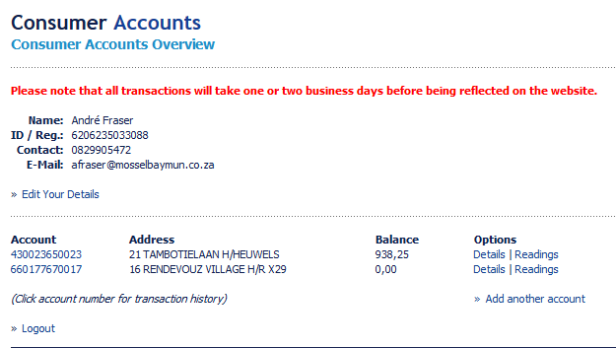

Account Transaction History
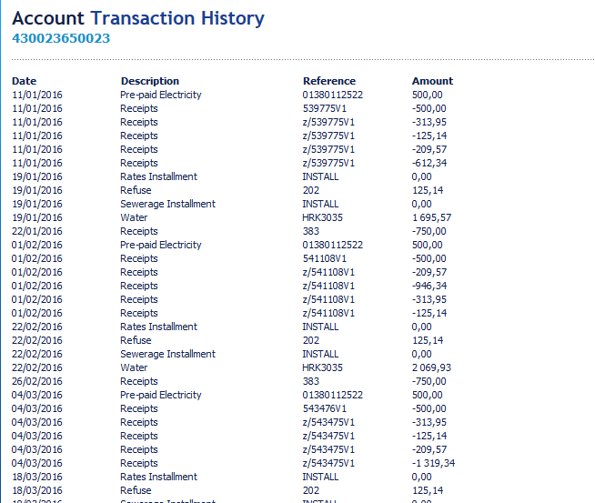

Consumer Account Details
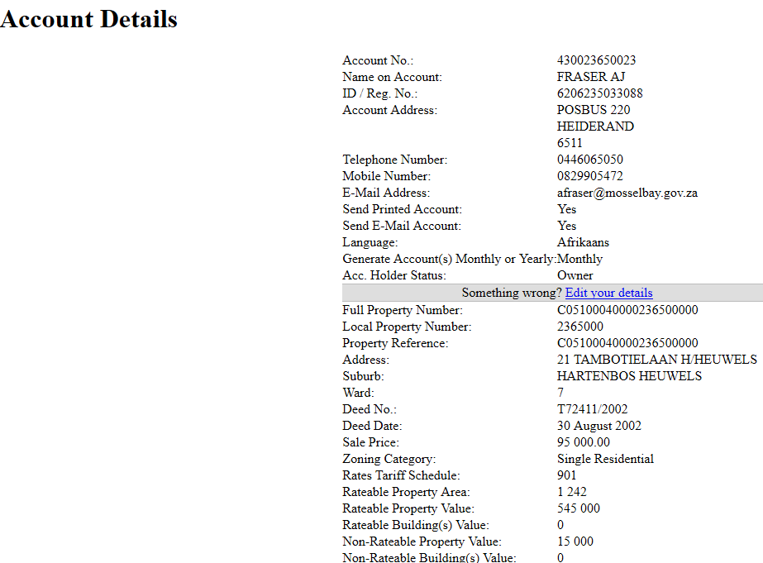

Administrator Functionality
There will be some functions an administrator be able to do.
- E-Mail Recipients: An administrator will be able to modify the recipient email address. These email address will be used to send errors in an email for registration and for any updates made by a client.
- View/Edit/delete consumer accounts

